EIGRP protocol:

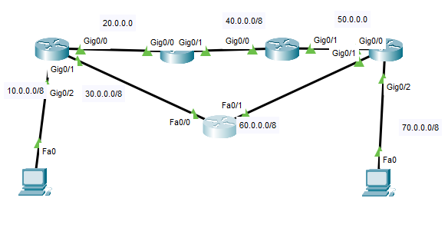

**Router 1:**

Router(config)#int g0/2

Router(config-if)#ip add 10.0.0.1 255.0.0.0

Router(config-if)#no sh

Router(config-if)#

Router(config-if)#int g0/1

Router(config-if)#ip add 30.0.0.1 255.0.0.0

Router(config-if)#no sh

Router(config-if)#int g0/0

Router(config-if)#ip add 20.0.0.1 255.0.0.0

Router(config-if)#no sh

Router(config-if)#exit

Router(config)#ip dhcp pool lanown

Router(dhcp-config)#default-router 10.0.0.1

Router(dhcp-config)#network 10.0.0.0 255.0.0.0

Router(dhcp-config)#dns-server 9.9.9.9

Router(dhcp-config)#do wr

Router(dhcp-config)#exit

Router(config)#do wr

Building configuration...

[OK]

Router(config)#router eigrp 100

Router(config-router)#do sh ip route

Codes: L - local, C - connected, S - static, R - RIP, M - mobile, B - BGP

D - EIGRP, EX - EIGRP external, O - OSPF, IA - OSPF inter area

N1 - OSPF NSSA external type 1, N2 - OSPF NSSA external type 2

E1 - OSPF external type 1, E2 - OSPF external type 2, E - EGP

i - IS-IS, L1 - IS-IS level-1, L2 - IS-IS level-2, ia - IS-IS inter area

* - candidate default, U - per-user static route, o - ODR

P - periodic downloaded static route

Gateway of last resort is not set

10.0.0.0/8 is variably subnetted, 2 subnets, 2 masks

C 10.0.0.0/8 is directly connected, GigabitEthernet0/2

L 10.0.0.1/32 is directly connected, GigabitEthernet0/2

20.0.0.0/8 is variably subnetted, 2 subnets, 2 masks

C 20.0.0.0/8 is directly connected, GigabitEthernet0/0

L 20.0.0.1/32 is directly connected, GigabitEthernet0/0

30.0.0.0/8 is variably subnetted, 2 subnets, 2 masks

C 30.0.0.0/8 is directly connected, GigabitEthernet0/1

L 30.0.0.1/32 is directly connected, GigabitEthernet0/1

Router(config-router)#network 10.0.0.0

Router(config-router)#network 20.0.0.0

Router(config-router)#network 30.0.0.0

Router(config-router)#no auto-summary

Router(config-router)#do wr

Building configuration...

[OK]

Router(config-router)#

%DUAL-5-NBRCHANGE: IP-EIGRP 100: Neighbor 20.0.0.2 (GigabitEthernet0/0) is up: new adjacency

**Router2:**

Router(config)#

Router(config)#int g0/0

Router(config-if)#ip add 20.0.0.2 255.0.0.0

Router(config-if)#no sh

Router(config-if)#int g0/1

Router(config-if)#ip add 40.0.0.1 255.0.0.0

Router(config-if)#no sh

Router(config-if)#do wr

Building configuration...

[OK]

Router(config-if)#

Router(config)#router eigrp 100

Router(config-router)#do sh ip route

Codes: L - local, C - connected, S - static, R - RIP, M - mobile, B - BGP

D - EIGRP, EX - EIGRP external, O - OSPF, IA - OSPF inter area

N1 - OSPF NSSA external type 1, N2 - OSPF NSSA external type 2

E1 - OSPF external type 1, E2 - OSPF external type 2, E - EGP

i - IS-IS, L1 - IS-IS level-1, L2 - IS-IS level-2, ia - IS-IS inter area

* - candidate default, U - per-user static route, o - ODR

P - periodic downloaded static route

Gateway of last resort is not set

20.0.0.0/8 is variably subnetted, 2 subnets, 2 masks

C 20.0.0.0/8 is directly connected, GigabitEthernet0/0

L 20.0.0.2/32 is directly connected, GigabitEthernet0/0

40.0.0.0/8 is variably subnetted, 2 subnets, 2 masks

C 40.0.0.0/8 is directly connected, GigabitEthernet0/1

L 40.0.0.1/32 is directly connected, GigabitEthernet0/1

Router(config-router)#netwo

Router(config-router)#network 20.0.0.0

Router(config-router)#

%DUAL-5-NBRCHANGE: IP-EIGRP 100: Neighbor 20.0.0.1 (GigabitEthernet0/0) is up: new adjacency

Router(config-router)#network 40.0.0.0

Router(config-router)#no auto-summary

Router(config-router)#do wr

Building configuration...

[OK]

**Router 3:**

Router(config)#

Router(config)#int g0/0

Router(config-if)#ip add 40.0.0.2 255.0.0.0

Router(config-if)#no sh

Router(config-if)#int g0/1

Router(config-if)#ip add 50.0.0.1 255.0.0.0

Router(config-if)#no sh

Router(config-if)#do wr

Building configuration...

[OK]

Router(config)#router eigrp 100

Router(config-router)#do sh ip route

Codes: L - local, C - connected, S - static, R - RIP, M - mobile, B - BGP

D - EIGRP, EX - EIGRP external, O - OSPF, IA - OSPF inter area

N1 - OSPF NSSA external type 1, N2 - OSPF NSSA external type 2

E1 - OSPF external type 1, E2 - OSPF external type 2, E - EGP

i - IS-IS, L1 - IS-IS level-1, L2 - IS-IS level-2, ia - IS-IS inter area

* - candidate default, U - per-user static route, o - ODR

P - periodic downloaded static route

Gateway of last resort is not set

40.0.0.0/8 is variably subnetted, 2 subnets, 2 masks

C 40.0.0.0/8 is directly connected, GigabitEthernet0/0

L 40.0.0.2/32 is directly connected, GigabitEthernet0/0

50.0.0.0/8 is variably subnetted, 2 subnets, 2 masks

C 50.0.0.0/8 is directly connected, GigabitEthernet0/1

L 50.0.0.1/32 is directly connected, GigabitEthernet0/1

Router(config-router)#netw

Router(config-router)#network 40.0.0.0

Router(config-router)#

%DUAL-5-NBRCHANGE: IP-EIGRP 100: Neighbor 40.0.0.1 (GigabitEthernet0/0) is up: new adjacency

Router(config-router)#network 50.0.0.0

Router(config-router)#no auto-summary

Router(config-router)#do wr

Building configuration...

[OK]

**Router4:**

Router(config)#int g0/0

Router(config-if)#ip add 50.0.0.2 255.0.0.0

Router(config-if)#no sh

Router(config-if)#int g0/1

Router(config-if)#ip add 60.0.0.1 255.0.0.0

Router(config-if)#no sh

Router(config-if)#

%LINK-5-CHANGED: Interface GigabitEthernet0/1, changed state to up

Router(config-if)#

Router(config-if)#int g0/2

Router(config-if)#ip add 70.0.0.1 255.0.0.0

Router(config-if)#no sh

Router(config-if)#exit

Router(config)#ip dhcp pool lanown

Router(dhcp-config)#default-router 70.0.0.1

Router(dhcp-config)#network 70.0.0.0 255.0.0.0

Router(dhcp-config)#dns-server 9.9.9.9

Router(dhcp-config)#exit

Router(config)#do wr

Building configuration...

[OK]

Router(config)#router eigrp 100

Router(config-router)#netw

Router(config-router)#network 50.0.0.0

Router(config-router)#

%DUAL-5-NBRCHANGE: IP-EIGRP 100: Neighbor 50.0.0.1 (GigabitEthernet0/0) is up: new adjacency

Router(config-router)#network 60.0.0.0

Router(config-router)#

%DUAL-5-NBRCHANGE: IP-EIGRP 100: Neighbor 60.0.0.2 (GigabitEthernet0/1) is up: new adjacency

network 60.0.0.0

Router(config-router)#network 70.0.0.0

Router(config-router)#no aut

Router(config-router)#no auto-summary

Router(config-router)#do wr

Building configuration...

[OK]

Router(config-router)#

Router(config-router)#

**Router 5:**

Router(config)#int f0/1

Router(config-if)#ip add 60.0.0.2 255.0.0.0

Router(config-if)#no sh

Router(config-if)#

Router(config-if)#int f0/0

Router(config-if)#ip add 30.0.0.2 255.0.0.0

Router(config-if)#no sh

Router(config-if)#exit

Router(config)#do wr

Building configuration...

[OK]

Router(config)#

Router(config)#

Router(config)#do sh ip route

Codes: C - connected, S - static, I - IGRP, R - RIP, M - mobile, B - BGP

D - EIGRP, EX - EIGRP external, O - OSPF, IA - OSPF inter area

N1 - OSPF NSSA external type 1, N2 - OSPF NSSA external type 2

E1 - OSPF external type 1, E2 - OSPF external type 2, E - EGP

i - IS-IS, L1 - IS-IS level-1, L2 - IS-IS level-2, ia - IS-IS inter area

* - candidate default, U - per-user static route, o - ODR

P - periodic downloaded static route

Gateway of last resort is not set

C 30.0.0.0/8 is directly connected, FastEthernet0/0

C 60.0.0.0/8 is directly connected, FastEthernet0/1

Router(config)#router eigrp 100

Router(config-router)#network 30.0.0.0

Router(config-router)#network 60.0.0.0

Router(config-router)#no auto-summary

Router(config-router)#do wr

Building configuration...

[OK]

Router(config-router)#

%DUAL-5-NBRCHANGE: IP-EIGRP 100: Neighbor 30.0.0.1 (FastEthernet0/0) is up: new adjacency

Router(config-router)#do wr

Building configuration...

[OK]

Let’s see how the trace command works:

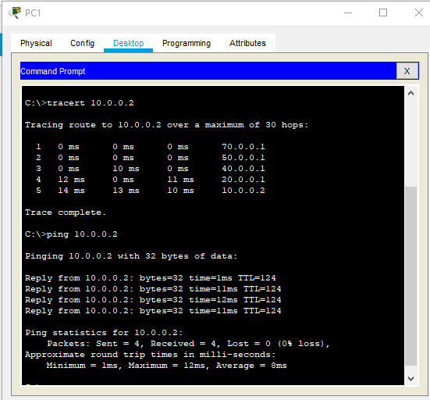

We see that the trace path is depends on the bandwidth. It follows gigabyte path though it have a shortest distance fast Ethernet way.